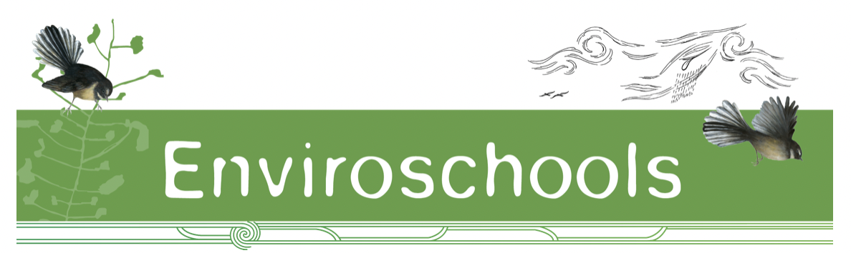
Ka mihi ki a Ranginui, ki a Papatūānuku,
Ka mihi ki te ngao o te wheiao,
Kia tau, kia tau, kia tau.

Kia ora koutou! Kōanga is upon us, the days are lengthening, and beautiful spring blossoms are out. We hope this pānui finds you well and looking forward to the last schooling term of the year. It’s lovely to be in touch to celebrate the mahi you are all doing and share some national kaupapa updates with you all.

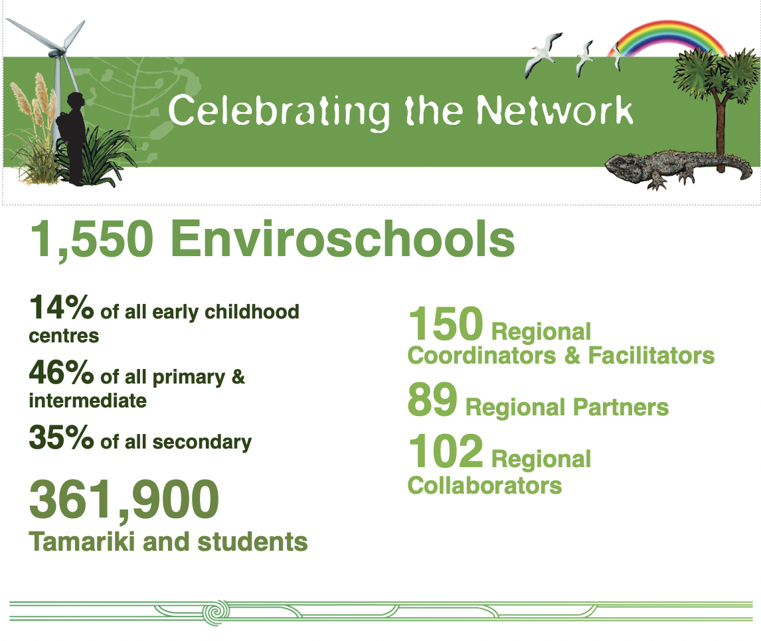
Celebrating our network and the beautiful connections, learning and mahi taking place

Ka nui te mihi ki a koutou! We mihi to you as facilitators and managers of the Enviroschools Kaupapa around the motu.

You are motivating, advising, guiding and inspiring kaiako and learning communities in beautiful collaborative ways, connecting to te taiao and making such positive change!

We celebrate all the people involved and give thanks to the organisations who are supporting our mahi.
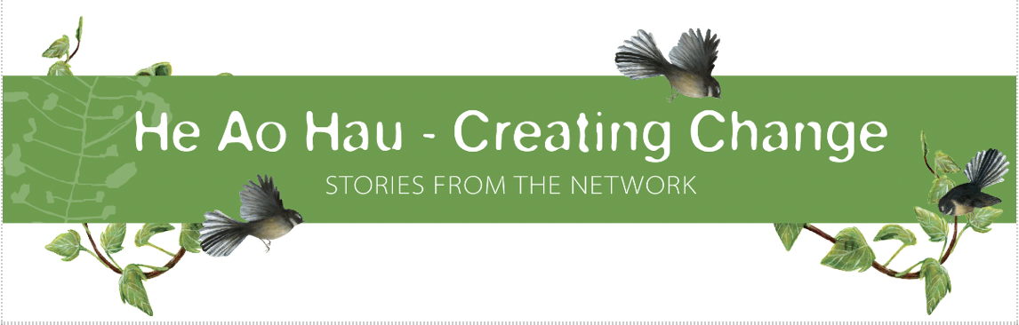

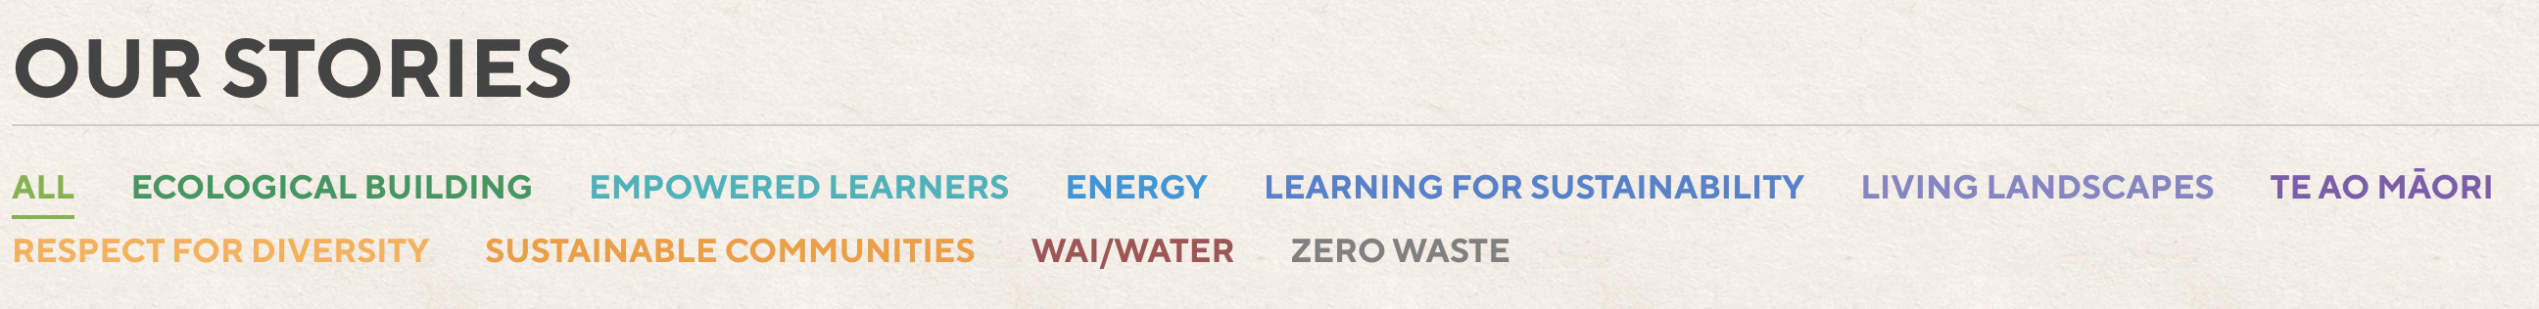

There are such amazing stories on our website thanks to the wonderful sharing from kaiako, facilitators and RCs, and great photos and snapshots coming through from #enviroschools
Here are links to a few recent stories and the social feed page so grab a cuppa and enjoy 😊

- Celebrating Student Leadership and vision in Ōamaru
- Wisdoms and insights from two decades as a Principal
- Our online puna mātauranga! #enviroschools

National Kaupapa and Resource Updates:

- Enviroschools Ngā Mātāpono - Guiding Principles development and changes:
Over the past few months we have been working through the process of change for three of our Guiding Principles. Thank you to those that have provided feedback and ideas. We are pleased to confirm the following changes:

- Māori Perspectives to ‘Te Ao Māori’
- Empowered Students to ‘Empowered Learners’
- Respect for Diversity of People and Cultures to ‘Respect for Diversity’

You can find the updated names and short descriptions:
- On our main website: https://enviroschools.org.nz/about-us/
- In the team area: https://enviroschools.org.nz/team-area/enviroschools-guiding-principles/

We have also updated the Ngā Mātāpono cards and these are available for download from this link:
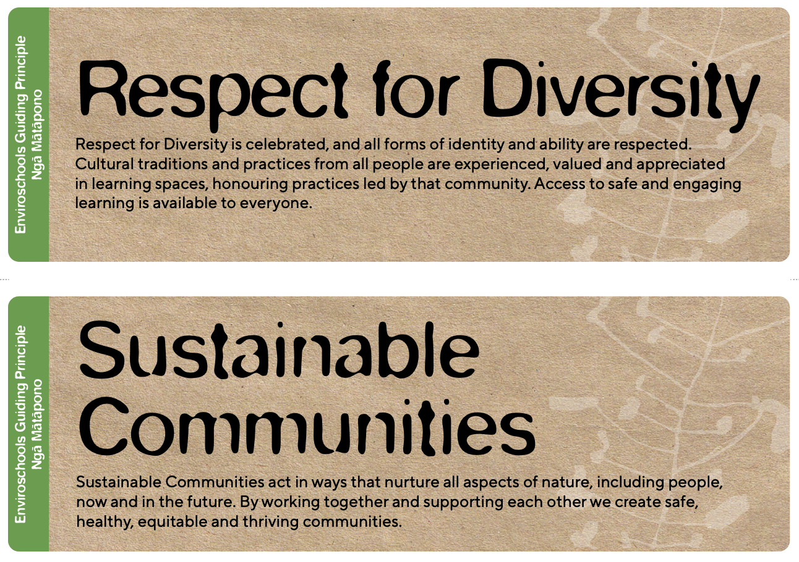
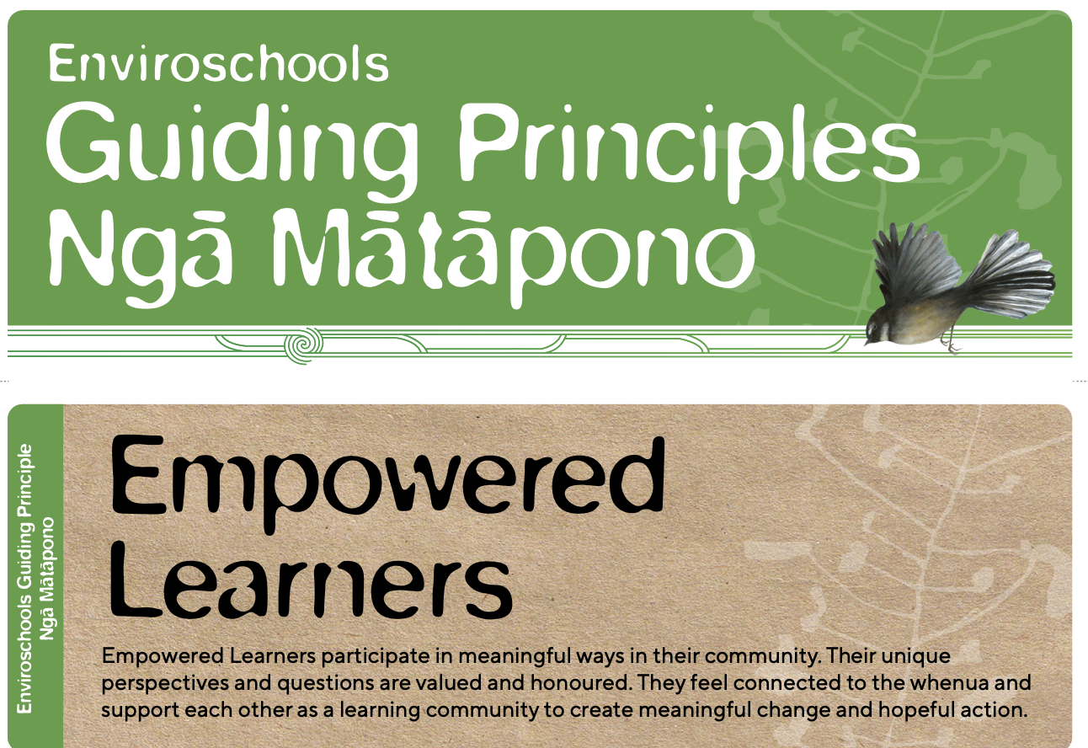
https://enviroschools.org.nz/team-area/guiding-principle-nga-matapono-cards/
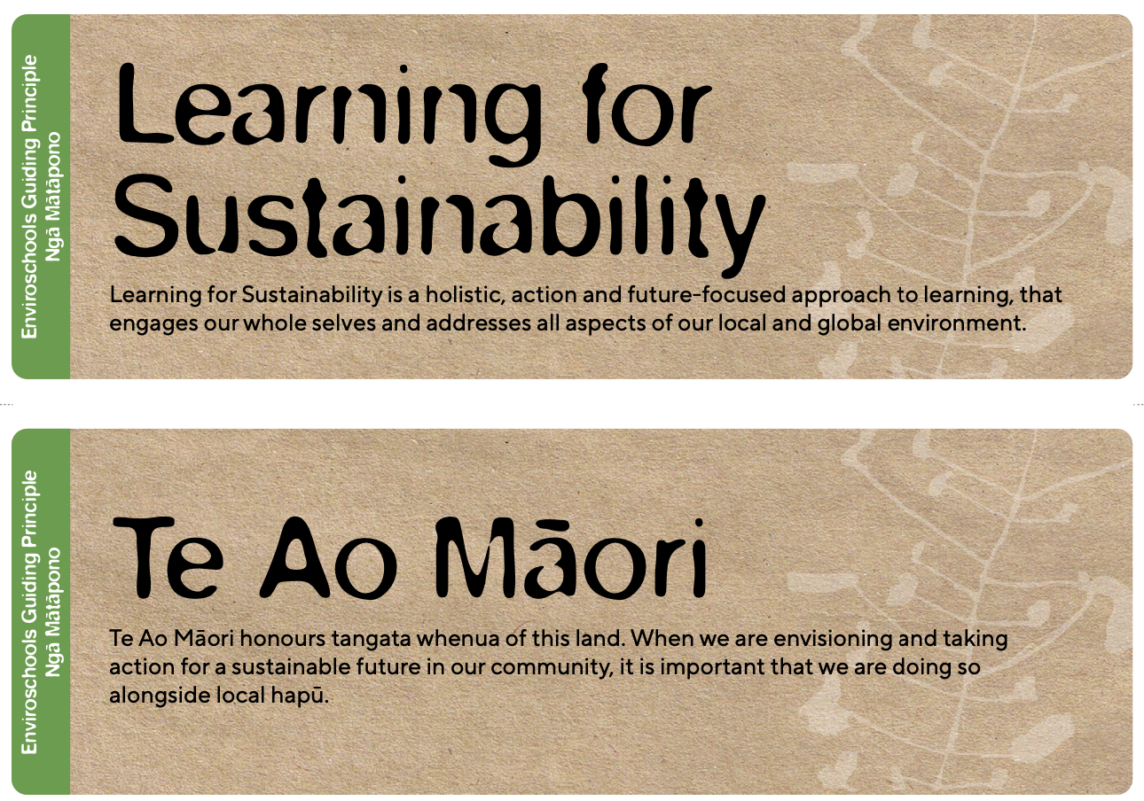
Over this term we will:
- Complete changes to key facilitation resources (Kaupapa A3 poster etc) and send out updates as these are finalised.
- Continue to share and kōrero about these changes at PDL opportunities (Deepening Practice Hui, ECE facilitator hui, Experiencing the Kaupapa Hui, Intro to Enviroschools hui, Regional Induction Hui, online zooms)
- Begin to make changes to physical resources (Kit, Handbooks) with the aim of having updated copies for printing in 2024.
- Host a whole network zoom to share progress and hold space for kōrero – 7th December – see below!

- Resource Development

The team have been busy with a range of other resources mahi designed to share and support the kaupapa and our holistic approach. We hope you find them useful in your facilitation and sharing.

*** Theme Area posters – available on the Team Area for download and printing:
- https://enviroschools.org.nz/team-area/theme-area-posters/
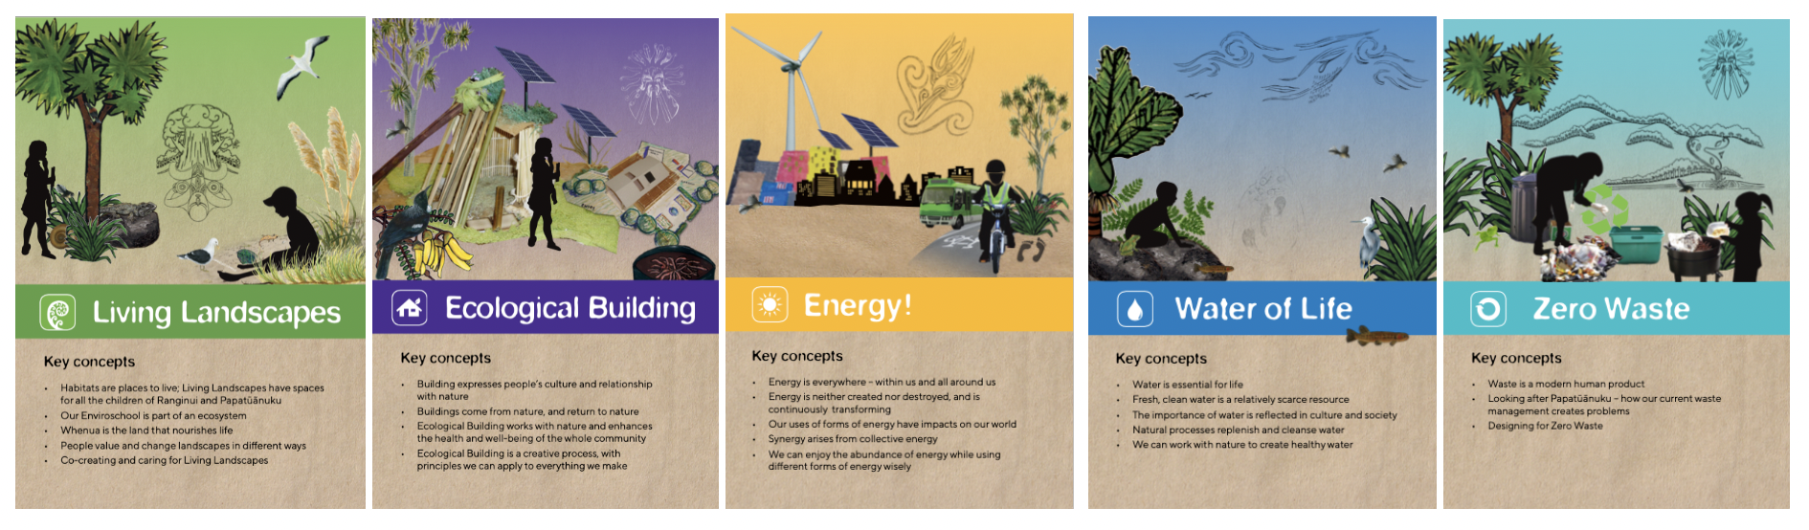

*** Climate Action and Just Transitions space

Some great mahi to share that’s highlighted on our News and Events page and in the Team Area.
Thanks to everyone involved in leading and supporting these spaces!

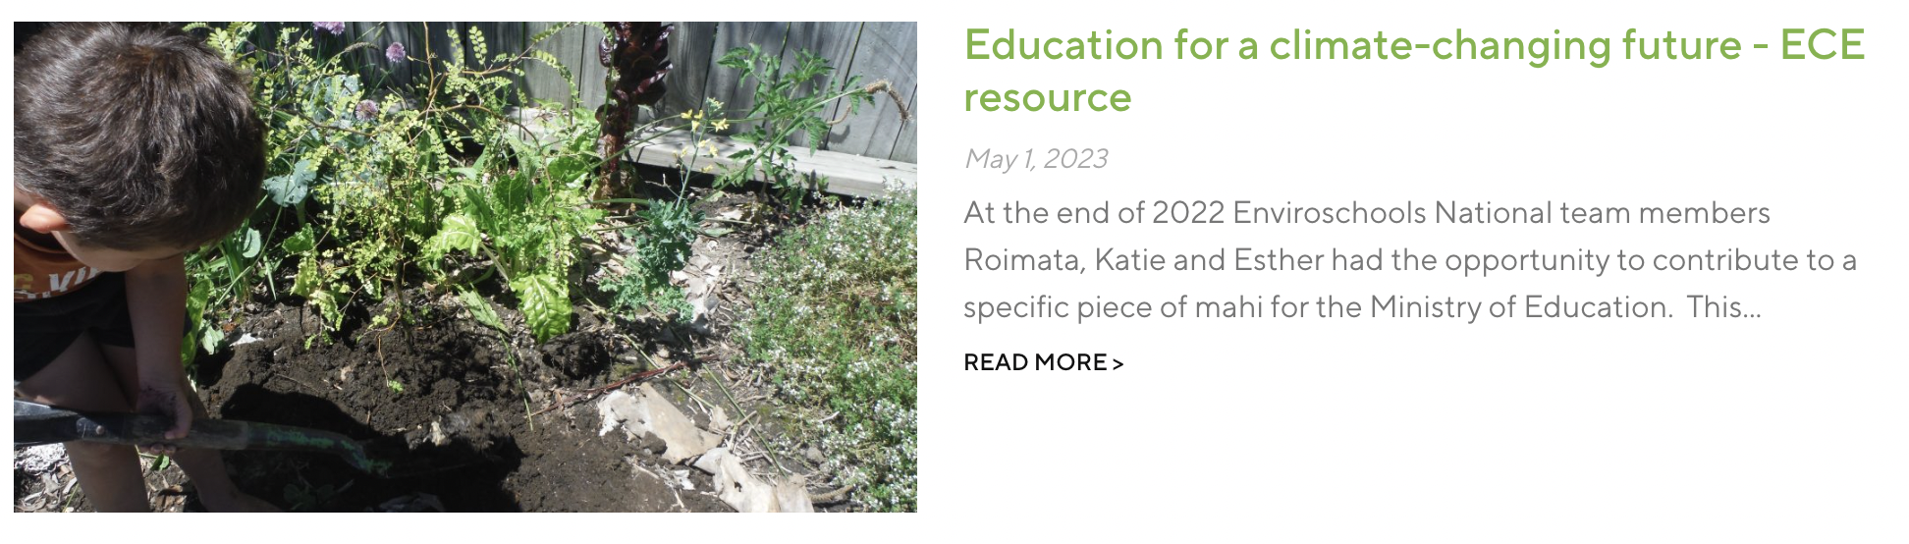
- Education for a Climate Changing Future: a website resource for kaiako in the ECE space.
- The Aotearoa Climate Education Coalition development of a website and position paper.
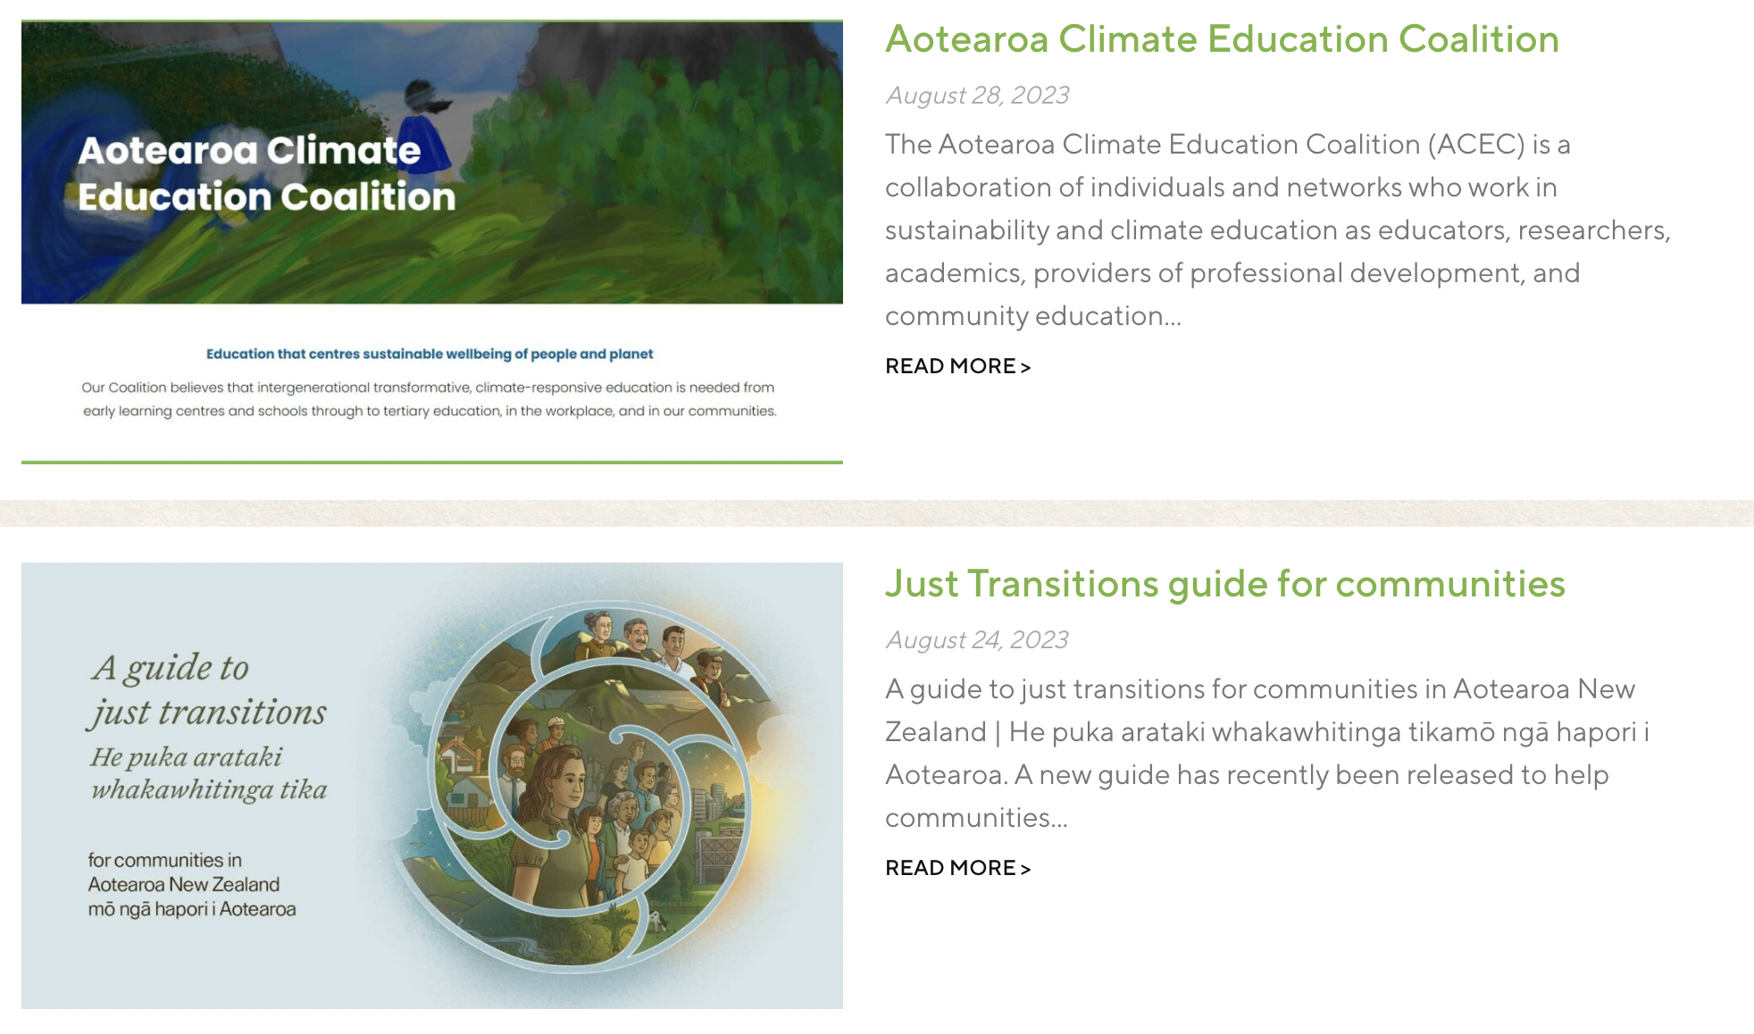
- Just Transitions Guide: a practical guide from MBIE that features a Toimata Foundation case study.
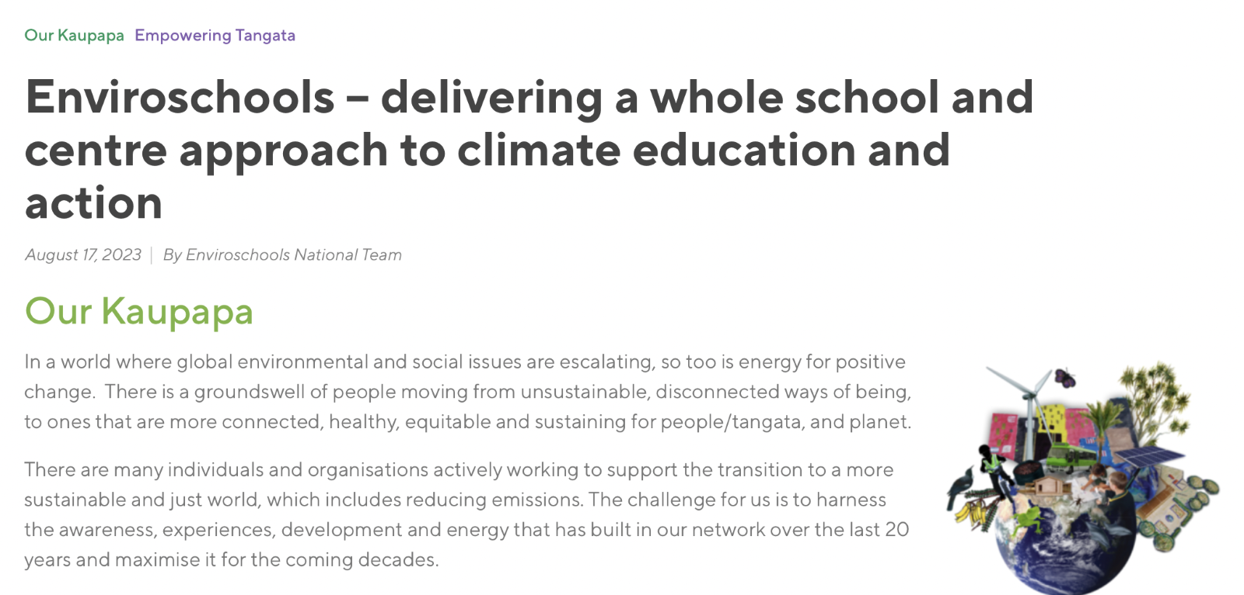
- Enviroschools – delivering a whole school/centre approach to climate action and empowerment – a new Team Area post

*** Coming up in the resources space:
- A range of tiles we can use in newsletters and social media celebrating the mahi our network is doing
- An A3 poster showing how our kaupapa is taking action for climate empowerment/a low emissions future
- Documents for Boards of Trustees: We are creating two documents for use by Boards of Trustees in centres and schools:
- BOT doc for Kindergarten Associations
- To be sent directly to KA Boards
- Purpose is to share the Enviroschools kaupapa, the network and partnerships, plus links to Te Whāriki and the National Education and Learning Priorities (NELP).
- School Boards of Trustees
- A document for facilitators to share with School Boards
- Purpose is to share the Enviroschools kaupapa, show how it is a close fit with the National Education and Learning Priorities (NELP), and give tools to Boards to help develop good processes for supporting the kaupapa, and set strategic direction.

- Predator Free Rangahau:

Thank you to all those from our Enviroschools network that took time to engage with this research conducted by Ally Palmer and Sally Birdsall of Auckland University. Ally has shared the findings that can be accessed here in this post on our website: https://enviroschools.org.nz/news-and-events/articles/ethics-education-and-eradication-predator-free-2050-in-schools-a-palmer-and-s-birdsall/

Robyn has added in the links to our kaupapa and what our network is doing – well worth the read so we can keep making the connections to the bigger picture 😊

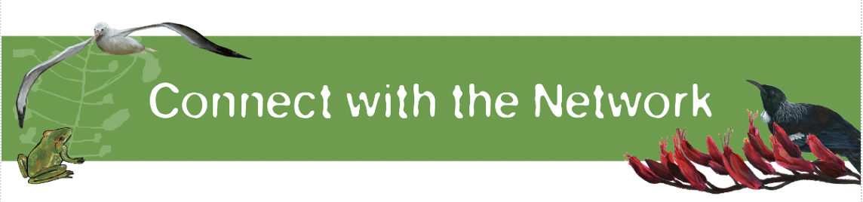

End of year Celebration Zoom for RC’s and Facilitators
We would like to invite you to a final online RC/Facilitator catch up for 2023 on 7 December from 10.30am – 12pm. A chance for us to come together, reflect on and celebrate our successes and achievements in 2023 and kōrero on the latest kaupapa developments.
- Register in advance for this huitopa:
  - https://us02web.zoom.us/meeting/register/tZUsce2grjMsH9Paaf5e7cL9C2fu3ORSsbIm
- After registering, you will receive a confirmation email with the meeting link to pop into your calendar

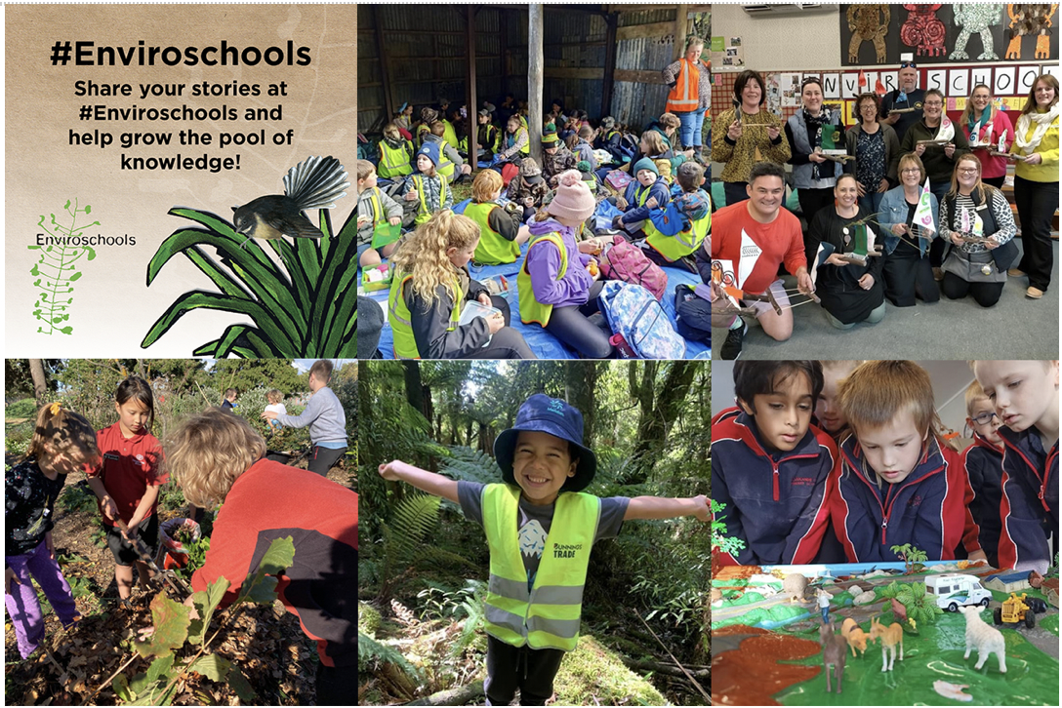

Remember if you have a story, fabulous event, learning moment, action or partnership highlight from your region to share, reach out to Anke and Robyn stories@enviroschools.org.nz or use #enviroschools

May the energies of te taiao continue to inspire and nourish you over this term. We look forward to seeing you online in December!

Ka nui te mihi,
Esther and the National Enviroschools team (Anke, Katie, Arihia, Robyn, Roimata, Beccy, Gill, Morag, Kristen)

