Climate Action Camp 2023 – DRAFT Runsheet (Yellow highlighted text is from 2022 runsheet - keep, edit or delete)
Monday 27th & Tuesday 28th March 2023
PIRONGIA FOREST PARK LODGE, 257 GREYS ROAD, PIRONGIA

Purpose: The Climate Camp is designed to support youth to understand more about climate change and what actions they could take together upon their return to school. Through a number of inspiring guest speakers, interactive workshops , outdoor and nature based activities they will build connection to the environment and each other with the support of their Enviroschools facilitators and teachers.

What do we want to achieve?
- Enable youth and experts to collaborate and develop key take-home messages and actions to help inform youth and community about the climate crisis.
- Educate rangatahi to identify key causes, impacts and risks of the climate crisis and the unique challenges and opportunities it presents to Waikato
- Build confidence and have fun through outdoor activity-based learning in Taiao
- Youth will identify a meaningful climate action initiative or campaign that they can implement on their return to school
- Youth connection to WRC’s Climate Action Roadmap implementation (Rick and Whitney: Climate Action work with Regional Council)

Time | Purpose | Activity | Facilitator | Resources / Who is responsible
Monday 27th March
8.00am | Team arrive and set up workspace.  Manaakitanga. Making space warm and inviting | Setting up space; snacks and hot drinks available on arrival  - Tables set up for morning tea -  - Chairs set up for Mihi Whakatau - horseshoe shape. Journals on chairs  - Set up Pool of Knowledge/Puna Mātauranga wall  - Decorate walls - Ideas; photos; resources; Big Picture etc.  - Connect with mana whenua and seek help? | Tātou | - Tea/Coffee/ milk etc  - Framework & Purpose  - Enviroschool banner  - Laptop linked to projector  - Journals  - POK  EFS booklets
8.30am | Team meeting
9.30am | School groups arrive and settle in | - Meet and greet; register and assign rooms -Anna  - Show to rooms - Jenni  - Name tag making – Ruairi/ Camilla  - Coffees for teachers – Alex  - Set up food – Michelle & Mesh  Rangatahi Voices can help? | Adrienne and Facilitators  Mesh and Rangatahi  Voices | - Register  - Name tags (wood circles) - Ruairi  - Magnolia Leaves – Alex  - Soft string - Adrienne  - Felt pens  - Speaker with music playing  Allocate teacher/adult in each dorm as the one ‘in charge’
10.00am | Mihi whakatau | - Karakia - Mesh  - Mihi & welcome – Adrienne  - Waiata – e tu kahikatea (3 verses)  - Introduction of facilitators, WRC staff, Rangatahi Voices  Facilitators and RV to be visually recognisable | Adrienne / Anna/ Mesh | AC & AG to liaise with Mesh
food | Morning tea | Karakia for kai |  | - Karakia written up
10.30am | Whakawhanaungatanga | Getting to know one another / ice-breakers (FUN!)  - Moving into the space (5 mins)  - Map activity / school group introduction (15 mins)  - Getting into activity groups (10 mins)  - Rangatahi Voices ice-breaker (15 mins) | Mapping – Ruairi  Activity Groups - Anna  Connecting ice-breaker – RV / Mesh | - Bell for timekeeping  - Map materials - Ruairi  - Atua cards?
11:15am | Scene Setting  Everyone understands purpose of workshop and knows what’s happening | - Purpose of Camp (Adrienne)  - Overview of two days (Adrienne)  - House keeping – Health and Safety, shoes off, phones, feelings, adults hold back - (Kate, Anna)  - Tikanga activity (brainstorm) - (Anna)  - Puna Mātauranga – introducing booklets as their PM/POK. Sharing the purpose/ how they can be used. - Hand out booklets  Keynote Speaker  - Intro for inspirational guest speaker - Sophie Handford, Councillor Kapiti District Council  - 10 min video with phone call Q&A afterwards - 02108947590 | Adrienne & Anna  Kate – H&S?  Anna & Jenni  RV to run Q&A - Seth | Workshop framework on wall  Large statement of purpose on wall  Booklets for each attendee (incl teachers)  PM/POK on wall  Phone connected to speaker
12.00 | Lunch | Rick & Whitney joining us? | Karakia  Kitchen Duty? | Eat on BBQ tables?
12:45pm | Understanding Climate Change | - What is your understanding of Climate Change?  - Explore what natural hazards are impacted by Climate Change  - Intro WRC Climate Roadmap – our response for the region.  - Increase temp – rainfall change – sea level rise. What areas of our lives will this impact?  - Intro Inundation tool, hazards portal – map out different scenarios eg changing landuse  - Share Wharekawa community case study of how this information has supported planning - Whitney  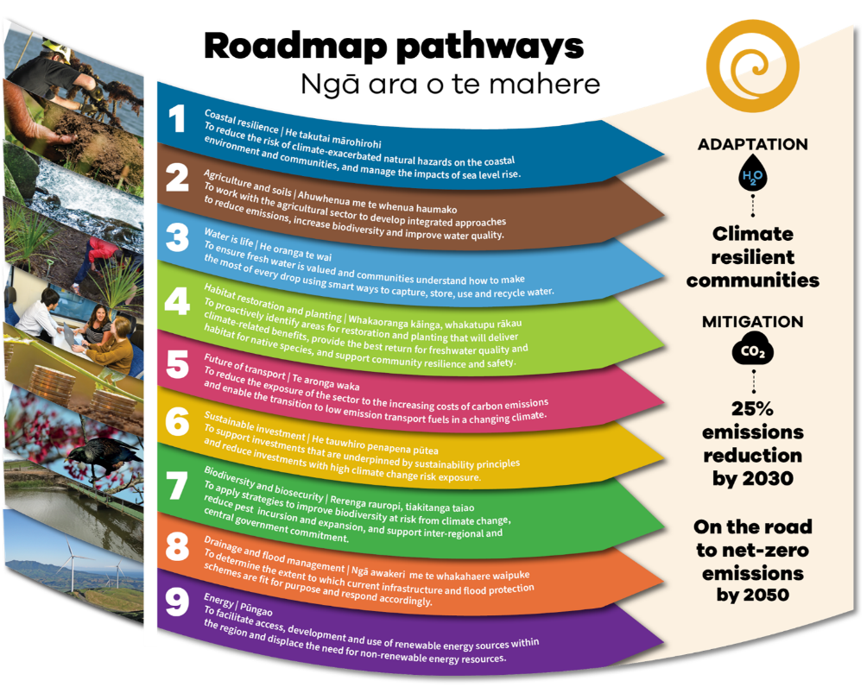 | Rick Liefting  Whitney Mills | Michelle to introduce?  Power point and WIFI  Feedback to Rick – inland effects (not just coastal) - Mesh to check in with Rick
1.45pm |  | Debrief (15 mins) from session - add key insights to POK | Cami & Jenni | Post-its for recording key concepts
2-5pm | 3 Rotations  (45 minutes per activity with 15 mins changeover) | Papatuānuku Ranginui Tānemahuta  2pm Climb Flying Fox Stream Study  3pm Flying Fox Stream Study Climbing  4pm Stream Study Climbing Flying Fox | Climb and Flying Fox with Kate - First Step Outdoors  Stream with Alex - Enviroschools | Afternoon Tea with group leads  Questions / discussion topics for group leads – Ruairi (leadership, taking risks etc...) -
 |  | Wet weather alternatives/locations?  Gazebo / Raincoats / Spare clothes bag  Alternative activities:  - Cloak of protection  - Ecosystems  - Decisions, Decisions  - FSO indoor options  - Alex-How much is Fresh? & Water is the Thread  - Jenni’s whanaungatanga activity  - Jeopardy! | Alex  Jenni  Adrienne | Gazebo - Ruairi
5.00pm | Free time before dinner | - Teachers support showers to occur  - WRC team debrief – include health and safety
6.00pm | Dinner | - RV to welcome councillors  - RV to thank and farewell councillors  Spontaneous waiata?  Reminder about bedtime tikanga / phone rules overnight / clear out rooms in the morning | Karakia  kitchen duty?  Alex
7.00pm | Rangatahi Voices Session | Purpose: Reflective Workshop  5 RV crew running the workshop | Rangatahi Voices
8.00pm - 9.30pm | Free time / Camp Fire | - Evening snack  - Set up camp fire  - Warm things (blankets etc) | Alex & Ruairi to start fire | Snacks – Anna & Adrienne  Teachers are in charge of their kids  Allocate teacher/adult in each dorm as the one ‘in charge’?  Phone rules overnight?
Tuesday 28th March
7.00am | Breakfast | - Breakfast  - Tidy and clear out of rooms (gear into vehicles) | Karakia  kitchen duty
8.15am | Energiser | Wake up and connect  Waiata | Jenni
8.30am | Nature awareness activities | Papatūānuku Tānemahuta Ranginui  Nature awareness Adrienne Nature awareness Anna Nature awareness Alex  - Initial guided meditation to ground group  - Sky Walking  - Meet a Tree  - Still Hunting  - Group reflection | set up hall for morning tea & climate panel | Adrienne to chat with Anna about Climate anxiety
9:20am | Making a difference | - Climate Conversation Cards  - Make notes in booklet  - Circles of influence / venn diagram in booklet.. | Cami | - Climate Conversation Cards
9.50am | Morning tea |  | Karakia
10.15am | Climate Panel – inspiring, sharing knowledge | My personal journey to my current role/ project/action  Confirm order, slideshow and comms  - Sustainable transport – Julie Hansen, WRC Senior Policy Advisor – Transport and Infrastructure  - University of Waikato – Professor Margaret Barbour, Dean of Science: research and introduce climate change degree  - Bachelor of Climate Change Student speaker -Lilian Balfour  - Lorraine Dixon - Project Advisor Taiao Team at Waikato Tainui - Portfolio in Climate Change  - Go Eco - Hannah Huggan  - Pirongia Restoration Society – Halle Aish, Youth Volunteer  - Holly Dove – Climate Activitist | Rangatahi Voice to MC and introduce speakers?  Adrienne to support  Anna - Tech support | Adrienne to compile slides into one powerpoint.  Koha for panelists - Plants? Petrol vouchers? WRC bags? - Mesh & Adrienne
11.45am | Reflection & Sharing | - Students invite to gather around Climate Panelist that they would like to ask questions of  - Make notes in your booklet  - Note down highlights/ curiosities to share for POK.  Waiata & gifts before lunch | Anna
12.00pm | Lunch |  | Karakia  kitchen duty
Take Action
12.45pm | Working on Climate Action initiative/idea | Set the scene, introduce next action planning session, refer to Venn diagram and A2 handout (5 mins)  In school groups with Facilitators & supporters as mentors  Take action- Create a climate action initiative or campaign  Action Plan development | Alex  Allocate facilitators & RV to schools | - Instructions for group leads - Alex  - Draft action planners  - A2x number schools (+3) - Alex  - Felts
2.00pm | Group sharing of action plan | - Presentation - Share Action Plan to present idea/action  - 5 mins per school  - MC – RV | School groups | - Sticky notes on Pool of Knowledge
3pm | Reflection and next steps with Afternoon Tea | Complete Feedback form over Afternoon tea.  1st 3 questions - write and reflect. Write and share with partner  - How are you feeling right now?  - What’s been the most helpful experience that you’ve had here?  - What’s one thing/idea that you are going take with you into the future?  As group – share one thing from your reflection. | Adrienne | - Reflection and Feedback sheet - Adrienne
3pm | Afternoon tea
3.30 | Pack down and clean up | Pack cars
3.50pm | Poroporoaki/ Farewell | Karakia  Thank you to Lodge staff  Waiata | Adrienne & Mesh
4.00pm | Depart camp

Roles:
Mesh – buying food & gift vouchers for presenters
Coordinators – Adrienne, Anna & Mesh
Youth Leadership – Rangatahi Voices
Photographer and comms – WRC (Mesh to follow-up)
Preparing kai - morning tea and lunch - Mesh
Registrations - Anna
Facilitator roles
- First Aiders- All Facilitators. First Aid Kit available in lodge and mobile kits available on activity rotations.
- Atua group support –Ruairi, Jenni, Cami
- Session delivery / support as detailed above
Health & Safety – first aid kit, COVID tests etc - Adrienne
Other:
- How are Māori perspectives/atua woven through?
- A facilitator needs to be present with their group to ensure time keeping and moderating.
- Facilitators -reminders to all teachers – to register. Teacher release is available for both days. Completion of FSO forms required of all attendees.
- Anything to add to gear list? Packed lunches and contribution to shared morning and afternoon tea – eg home baking, slippers/socks for inside, wet weather gear, multiple changes of clothes, towel,
- Michelle to arrange fruit, Mother Earth snacks (Toimata), koha for guest speakers, WRC first aid and sanitiser
- Catering arranged for Dinner, Breakfast and Thursday Lunch
- Site visit for hazard identification and session planning including wet weather options: Wet weather alternatives for Connection activities??
- Evaluation design
- Determine brief for Intro session
- Weaving threads through: sustainability of self in your climate journey developing an climate action plan for schools + personal responsibility – when to yes/ when to say no. . . .looking after yourselves/ burnout.
- During outdoor activities – facilitators to ‘explore alternatives’/ develop ideas for climate action plan – this needs to be built through the whole two days.
- Creating/ setting tone and vibe for the day . . . .

- Other:
- Mihi whakatau
- Duty of Care
- Groups – schools mixing
- Dinner with Councillors
- Journal for students

Resources | Who
Vintage Blankets x 4 +3 | Adrienne +Jenni
Games:  Cloak of protection  Ecosystem  Exploding Kittens | Adrienne
Atua posters/ Karakia | Adrienne
Pale blue dot poster | Adrienne
String for name tags | Adrienne
Large colourful Table cloth x 1 | Adrienne
Wooden name tags x 50 | Ruairi
Facilitation kit  - Blue tack  - Colour pencils | Adrienne
Sticky labels for spare name tags | Michelle
Whiteboard pens – a range of colours | Michelle
Sharpies – for writing names on name tags | Michelle
A2 Flip charts | Michelle
Sticky notes | Michelle
Felt pens | Michelle
Scrap paper | Michelle
Glue sticks | Michelle and etc
COVID Tests

