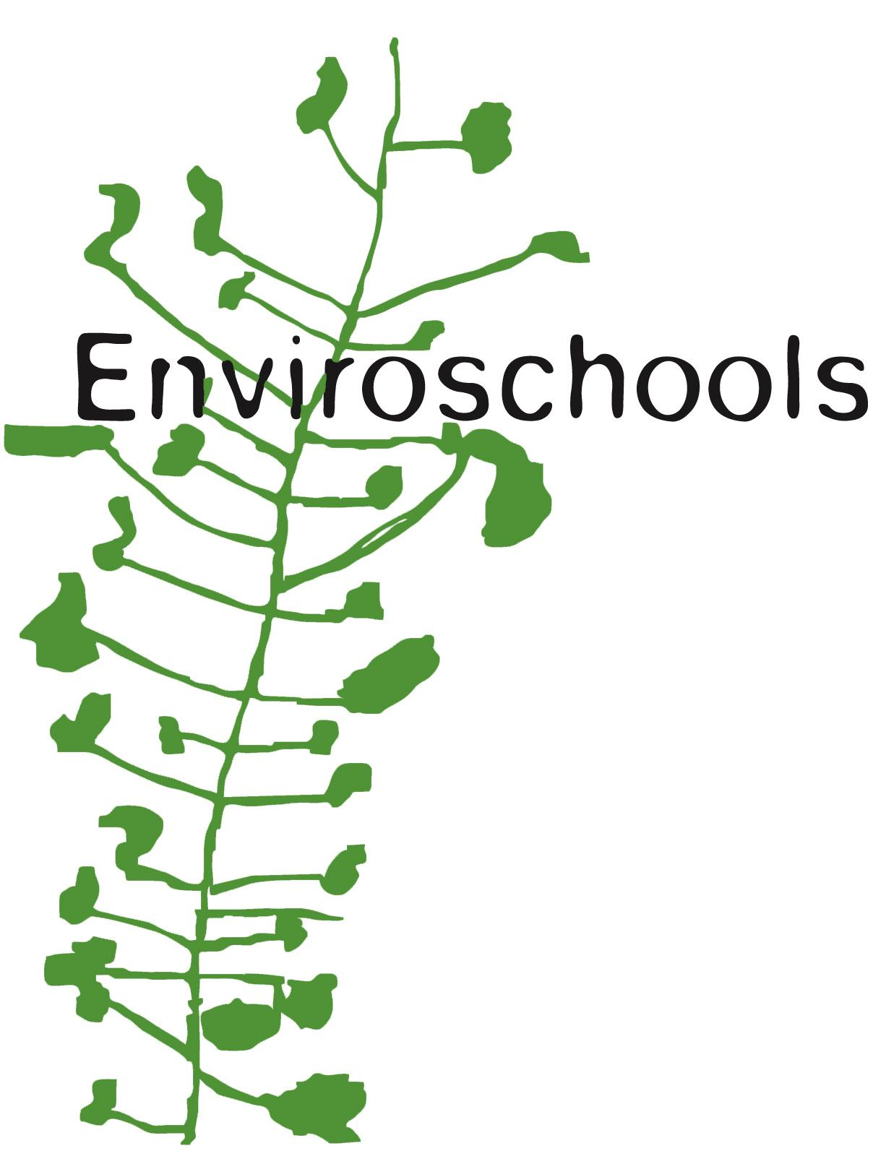
Water of Life Encounters Taupō 2024
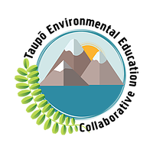
Initiated by Waikato Enviroschools facilitator, Jenni Scothern-King, in collaboration with Tongariro National Trout Center, Contact Energy, Genesis Energy and Taupō EEC.
21 - 22 March 2024 https://www.worldwaterday.org/
10am to 1.45pm
The Purpose:
To provide an interactive/experiential learning opportunity for akonga and kaiako to::
    - gain a deeper appreciation of the vital role clean water plays in our community.
    - consider actions needed in order to minimise negative impacts on waterways.
    - realise and value the inseparable connection between atmosphere, land, and water.
    - gain some scientific understandings relating to water quality and how to check for water quality.
- A collaboration of entities concerned with water quality, water uses and water conservation.
- Inspire a deepened connection with the role water plays in our lives and how to mitigate for future water security.
- Inspire empowerment of students to lead changes in attitudes and sense of responsibility in their community, promoting kaitiakitanga values and actions concerning water.
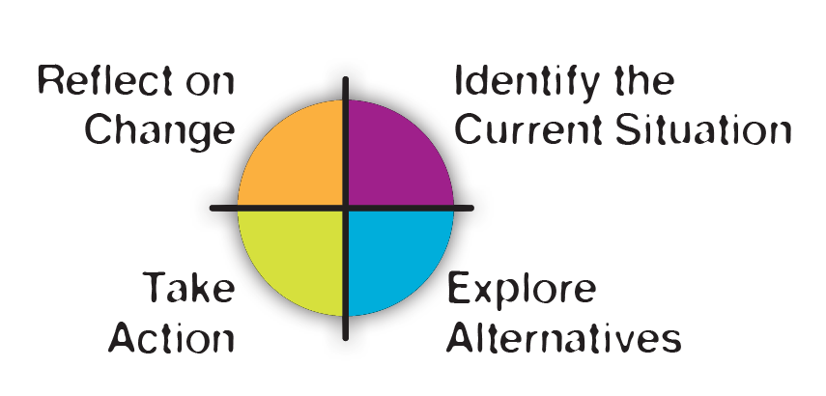
- Provide opportunities to deepen learning by hearing from ‘experts’ and to encourage extension to their learning through taking action locally.

N.B. Enviroschools follows an Action Learning Cycle to promote deep learning and action…

This year we plan to run two days to allow for longer station rotations with a 20 minute lunch break.

Key Concepts from Enviroschools Water of Life Theme Area
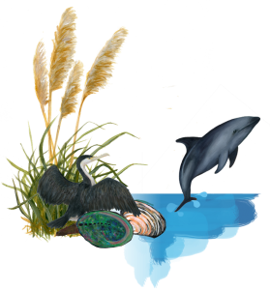
Water is essential for life, and the abundance or scarcity of clean water is a major influence on which life forms can exist in a place.
Raindrops falling from the sky are the tears shed by Ranginui in his longing for Papatūānuku, while the rising mist shows her enduring love directed up towards him in return. The Water of Life – Wai Ora – carries this mauri of aroha as it cycles endlessly through our atmosphere, land, and waterways. Water is also a good environmental indicator, and the state of our waterways tells us a lot about our relationship with nature and the health of our community.
Through the Enviroschools Water of Life theme area, teachers can delve into all of these concepts (link live for Enviroschools members only)Main emphasis at Event: are Concepts b) and e)
There are five Key Concepts in Enviroschools Water of Life Theme Area to explore:
a) Water is essential for life
b) Fresh, clean water is a relatively scarce resource
c) The importance of water is reflected in culture and society
d) Natural processes replenish and cleanse water
e) People can work with nature to create healthy water

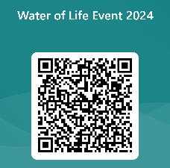
CONTACT Energy has generously offered to sponsor bus transport again, for schools to attend this Event. They are happy for Genesis Energy, the local energy producer, to present this year.
Please register your availability. Scan the QR code or click the link https://forms.office.com/r/eHHFdRi9ud
The Process:
There will be 7 activity/ presentation stations set up at the venue each day, with an ‘expert’ at each station to engage with students.
We will have a 20-minute lunch break. Last year we subsidised sausages and bread. TBC this year.

Each presenter or educator will provide an activity in a meaningful local context to share important information relating to their area of expertise, with an emphasis on interactive experiences or demonstrations.
20 minutes at each station. (additional 5 minutes changeover time) ie. 25 minutes per rotation.
There will be about 10 students at any station at any given time.
A booklet for each student will be printed, with questions to answer
Some stations are inside the Trout Centre main building. Others are located along the trail beside a spring-fed stream teeming with wild trout, in the kiosk and in the onsite classroom.

2024 Presentations rotation will include:
*National Trout Centre
-Macroinvertebrates as indicators of water health, observe and identify
-Native species in our local waterways –galaxids, tuna (eels) and others in the Trout Centre Aquarium
-Aquaponics explained (presenter from Christchurch
*NIWA- a glimpse into the life of a NIWA field scientist. Nicky Sharp
*Taupō District Council –litter in waterways recovered (cleaned) from our waterways Shannon, Melissa
*Waikato Regional Council
-Flooding events- Phil Mourot why and how we can reduce floods or their effects; interactive model (TBC)
-Water quality – Enviroschools – using water monitoring tools
*Genesis Energy – Electricity generation in the Tūrangi rohe
*Kids Greening Taupō – with Centre caretaker Planting and mulching for stabilising bank –Waihukahuka stream; historical background of acquisition of this property
*Ministry of Education – Local curriculum Aotearoa NZ Histories–stories about some catchment place names of significance to Tūwharetoa – with visual arts component
*Litta traps – invisible trash- Suzie Lamb heavy metals and dissolved nutrients with Filterra and
LittaTrap for Visual Trash capture.
Also invited: eDNA expert; gold clams and other freshwater pests ‘expert’

*Dept Internal Affairs –A glimpse into life as a Taupō Harbourmaster, (TBC)
* MPI, DOC – Pest species in our local waterways (TBC)

2024 Timetable on each day: Welcome at 10am
8 Rotations every 25 mins,
10.15am -12.05pm Lunch break. Rotations resume 12.25pm - 1.40pm; Buses depart 1.45pm

Mō tātou te taiao ko te atawhai, mō tātou te taiao ko te oranga.
By caring for and looking after our environment, we ensure our own wellbeing and that of our future generations.

Contact Jenni: Ph: 021 293 2434 Email: jennifer.scothern-king@waikatoregion.govt.nz

